**Lab-4 Inheritance**

1. Write a program of single inheritance :

Base Class : B

* Private member : a (int)
* Public member: b (int)

Derived Class : D

* Private member : c (int)

Calculate c = a* b and display

**a) public derivation**

**b) private derivation.**

2. Solve the following problem for Multilevel Inheritance:

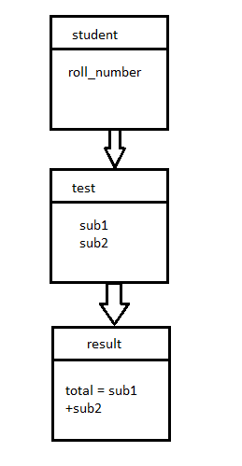

3. Solve the following form of multiple inheritance

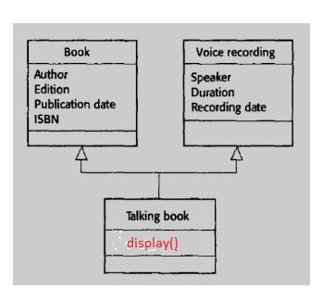

4. Solve the following form of Hybrid Inheritance.

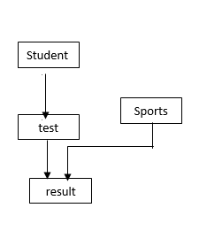

5. Solve the following form of inheritance making one constructor in each class.

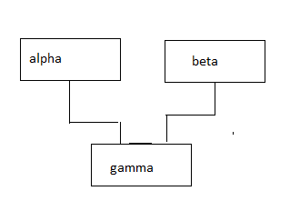

6. Solve Q. No. 5 adding destructor in each class.